**Part 4 - Working with Service**

Please follow these instruction if all you guys wanna work with services

Step 1 : Add “Data” directory within “src directory”

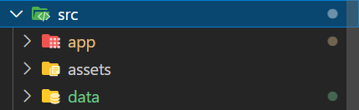

Once you have done with that, You have to register this folder/directory in angular.json. Otherwise you won’t be able use the new directory

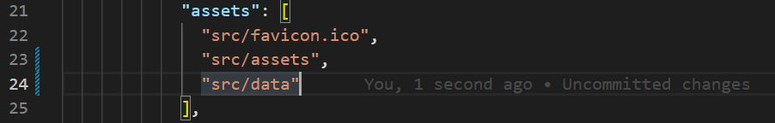

Step 2 : Add json file within data directory. And fill with json data format

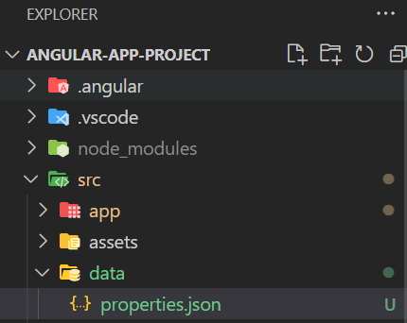

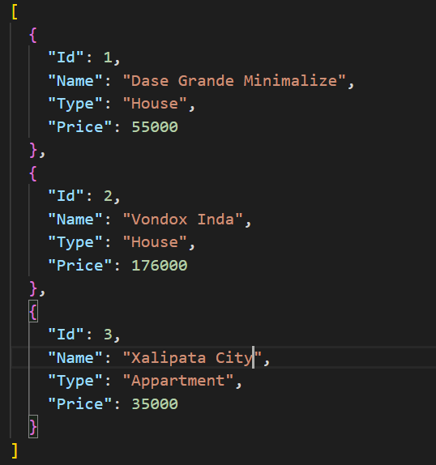

Step 3 : Create “service” directory, then generate service using bellow command

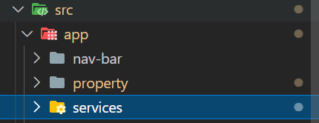



Step 4 : Define your method / function of client service

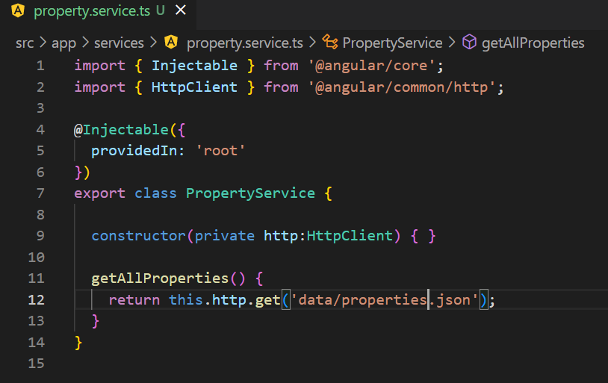

|  |
| --- |
| - getAllProperties will return observable. It means, in the service caller (in this case is component), you have to call subscribe method to see the actual data |

Step 5 : Call the service from the component like this below image

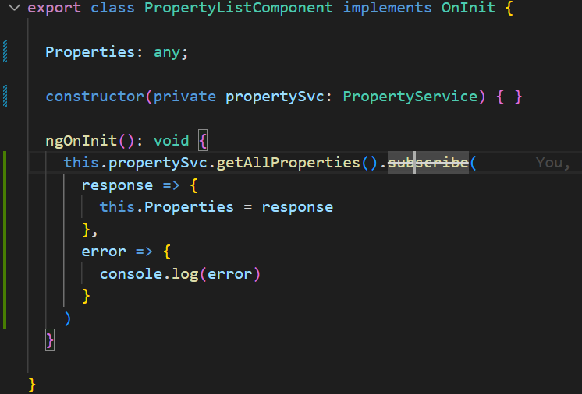

Don’t forget to register your service in app.module.ts

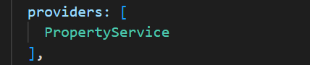

Reference :

<https://www.youtube.com/watch?v=YSfY7DcfDQM&list=PL_NVFNExoAxclqXo9fLAeP0G2Qp56Fu8C&index=10>

[https://www.youtube.com/watch?v=JuJgWSI8sMc&list=PL_NVFNExoAxclqXo9fLAeP0G2Qp56Fu8C&index=11](https://www.youtube.com/watch?v=YSfY7DcfDQM&list=PL_NVFNExoAxclqXo9fLAeP0G2Qp56Fu8C&index=10)

**[IMPLEMENT OBSERVABLE](https://www.youtube.com/watch?v=YSfY7DcfDQM&list=PL_NVFNExoAxclqXo9fLAeP0G2Qp56Fu8C&index=10)**

[Step 1 , Create Interface](https://www.youtube.com/watch?v=YSfY7DcfDQM&list=PL_NVFNExoAxclqXo9fLAeP0G2Qp56Fu8C&index=10)

[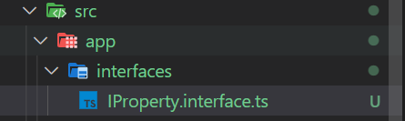](https://www.youtube.com/watch?v=YSfY7DcfDQM&list=PL_NVFNExoAxclqXo9fLAeP0G2Qp56Fu8C&index=10)

[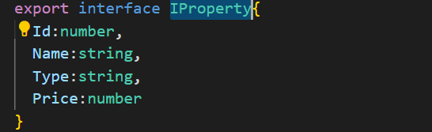](https://www.youtube.com/watch?v=YSfY7DcfDQM&list=PL_NVFNExoAxclqXo9fLAeP0G2Qp56Fu8C&index=10)

[Step 2, Change the method in service (property.service.ts)](https://www.youtube.com/watch?v=YSfY7DcfDQM&list=PL_NVFNExoAxclqXo9fLAeP0G2Qp56Fu8C&index=10)

[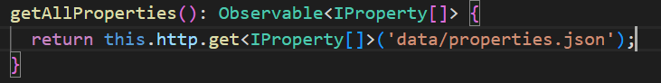](https://www.youtube.com/watch?v=YSfY7DcfDQM&list=PL_NVFNExoAxclqXo9fLAeP0G2Qp56Fu8C&index=10)

[Step 3, Change varible "Properties" into the type (property-list.component.ts)](https://www.youtube.com/watch?v=YSfY7DcfDQM&list=PL_NVFNExoAxclqXo9fLAeP0G2Qp56Fu8C&index=10)

[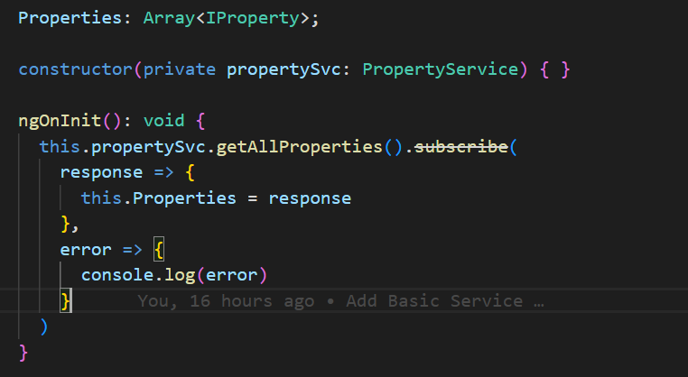](https://www.youtube.com/watch?v=YSfY7DcfDQM&list=PL_NVFNExoAxclqXo9fLAeP0G2Qp56Fu8C&index=10)

[Step 4, change at Input decorator](https://www.youtube.com/watch?v=YSfY7DcfDQM&list=PL_NVFNExoAxclqXo9fLAeP0G2Qp56Fu8C&index=10)

[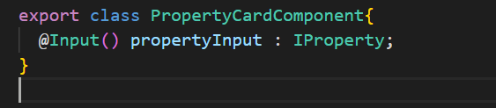](https://www.youtube.com/watch?v=YSfY7DcfDQM&list=PL_NVFNExoAxclqXo9fLAeP0G2Qp56Fu8C&index=10)